S.No | Category | S.No | Topic
1 | Networking Fundamentals | 1 | OSI Model
 |  | 2 | TCP Header
 |  | 3 | IP Header
 |  | 4 | TCP Three-Way Handshake
 |  | 5 | TCP Options
 |  | 6 | TCP Flags
 |  | 7 | TCP Timers
2 | Network Protocols & Services | 8 | Address Resolution Protocol (ARP) & Types of ARP
 |  | 9 | Dynamic Host Configuration Protocol (DHCP)
 |  | 10 | Domain Name System (DNS)
 |  | 11 | DNS over HTTP (DoH)
3 | Network Diagnostic Tools | 12 | Ping: How it works
 |  | 13 | Traceroute: How it works
 |  | 14 | Telnet
4 | HTTP / Web Protocols | 15 | HTTP vs HTTPS
 |  | 16 | HTTP Request Methods
 |  | 17 | HTTP Response Codes
 |  | 18 | Browser Header Traces
5 | TLS / SSL Security | 19 | TLS Handshake
 |  | 20 | SSL Handshake (Certificate validation, Intermediate CA, Root CA)
 |  | 21 | How client verifies the server certificate
 |  | 22 | SNI (Server Name Indication)
 |  | 23 | Subject Alternative Name (SAN)
 |  | 24 | TLS 1.2 Handshake (Detailed)
 |  | 25 | TLS 1.3 Handshake (Detailed)
6 | VPN & Tunneling Technologies | 26 | GRE (Generic Routing Encapsulation)
 |  | 27 | IPsec
 |  | 28 | GRE vs IPsec
 |  | 29 | NAT Traversal (NAT-T)
 |  | 30 | IPsec IKEv1 Main Mode (6 packets with payloads)
 |  | 31 | IPsec IKEv1 Aggressive Mode (4 packets with payloads)
 |  | 32 | IPsec Quick Mode (with payloads)
7 | Identity & Authentication | 33 | SAML (IdP Initiated Flow)
 |  | 34 | SAML (SP Initiated Flow)
 |  | 35 | Authentication using SAML: How it works
 |  | 36 | SCIM
8 | Zero Trust & Zscaler | 37 | Zero Trust Architecture
 |  | 38 | Overview of Zscaler Products (ZIA, ZPA)
9 | Network Security & Infrastructure | 39 | Explain about Proxy and working of Proxy
 |  | 40 | Explain about Firewall and working of Firewall
 |  | 41 | Difference between Proxy and Firewall
10 | Network Troubleshooting | 42 | Troubleshooting latency issues using Wireshark

Networking Fundamentals
- What is OSI Model?
The OSI (Open Systems Interconnection) Model is a 7-layer conceptual framework developed by the International Organization for Standardization (ISO). It explains how data travels from one computer to another over a network and how different computer systems communicate with each other. Each layer has specific functions and responsibilities, which helps standardize communication and allows different devices and technologies to work together
Layers of OSI Model
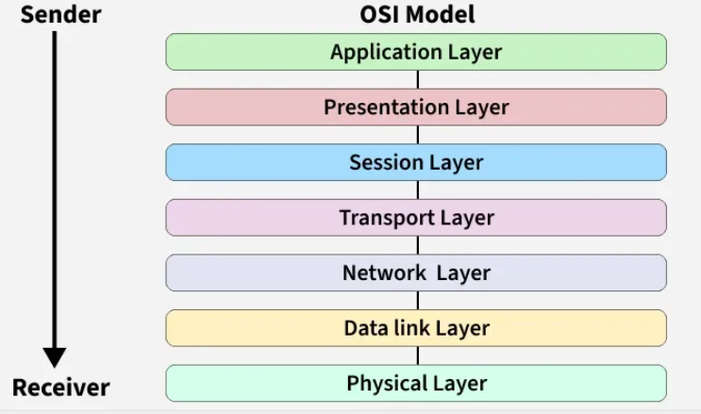

S.No | Layer | Working | Protocol Data Unit | Protocols
1 | Physical Layer | Establishing Physical Connections between Devices. | Bits | USB, SONET/SDH, etc.
2 | DataLink Layer | Node to Node Delivery of Message. | Frames | Ethernet, PPP, etc.
3 | Network Layer | Transmission of data from one host to another,  located in different networks. | Packets | IP, ICMP, IGMP, OSPF, etc.
4 | Transport Layer | Take Service from Network Layer and provide it to  the Application Layer. | Segments (for TCP) or Datagrams (for UDP) | TCP, UDP, SCTP, etc.
5 | Session Layer | Establishes Connection, Maintenance, Ensures  Authentication and Ensures security. | Data | NetBIOS, RPC, PPTP, etc.
6 | Presentation Layer | Data from the application layer is extracted and  manipulated in the required format for transmission. | Data | TLS/SSL, MIME, etc.
7 | Application Layer | Helps in identifying the client and synchronizing communication. | Data | FTP, SMTP, DNS, DHCP, etc.

- Transmission Control Protocol (TCP) header
TCP (Transmission Control Protocol) is a reliable transport protocol as it establishes a connection before sending any data and everything that it sends is acknowledged by the receiver

When computers send data over the internet, they don’t send it as one big file. They break it into small pieces called TCP segments. Each segment has two parts:
- Header → Control information (like instructions)
- Data → The actual message
👉 TCP Header = A small block of information attached before the data so the receiver knows how to handle it.

Real Life Example:
Imagine you send 5 pages of a document by courier in 5 separate envelopes. On each envelope you write
- From address
- To address
- Page number (1/5, 2/5…)
- Special instructions
That label = TCP Header
The papers inside = Actual Data
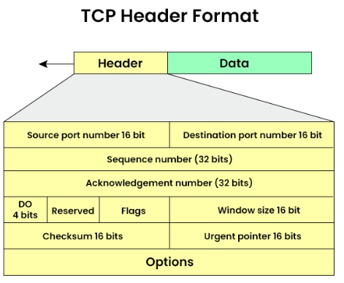

TCP HEADER STRUCTURE (20–60 Bytes)
Field | Size | Purpose | Related TCP Feature
Source Port | 16 bits | Sender application port | Process-to-process delivery
Destination Port | 16 bits | Receiver application port | Process-to-process delivery
Sequence Number | 32 bits | Order of bytes sent | Reliable & Ordered delivery
Acknowledgment Number | 32 bits | Next expected byte | Reliability (ACK)
Header Length | 4 bits | Size of TCP header | Proper data parsing
Reserved | 6 bits | Future use | —
Flags (URG, ACK, PSH, RST, SYN, FIN) | 6 bits | Control connection | Connection setup & termination
Window Size | 16 bits | How much data receiver can accept | Flow Control
Checksum | 16 bits | Error checking | Error Control
Urgent Pointer | 16 bits | Urgent data position | Special data handling
Options (Optional) | 0–40 bytes | Extra features (MSS, scaling) | Performance & Congestion control

- IP header or IPv4 packet header
IPv4 stands for Internet Protocol version 4 is the addressing system which assigns unique labels to devices on the internet. You can think of IPv4 as the address label on a package you are sending in the mail. Just like the label includes information about the sender, receiver, and nature of the contents, the IPv4 Header also contains information regarding the data that is being sent over the internet.

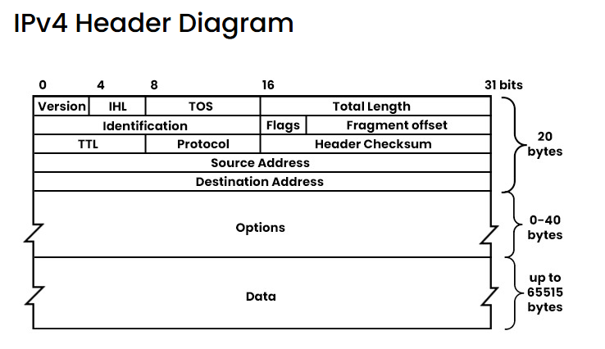
Field | Size | Purpose (Easy Meaning)
Version | 4 bits | Tells IP version. For IPv4, value is 4.
IHL (Internet Header Length) | 4 bits | Header length. Minimum is 20 bytes, can be more if options are used.
TOS (Type of Service) / DSCP | 8 bits | Tells network how to treat the packet (priority, delay, reliability). Used for QoS.
Total Length | 16 bits | Full packet size = Header + Data. Max = 65,535 bytes.
Identification | 16 bits | Used to identify fragments of the same original packet. Important during fragmentation.
Flags | 3 bits | Controls fragmentation.  • 1 bit unused  • DF = Don’t Fragment  • MF = More Fragments coming
Fragment Offset | 13 bits | Tells where this fragment belongs in the original packet.
TTL (Time to Live) | 8 bits | Limits how long packet can travel. Reduced by 1 at each router. If it reaches 0, packet is dropped. Prevents infinite looping.
Protocol | 8 bits | Tells which protocol is inside the data part.  Examples: 6 = TCP, 17 = UDP, 1 = ICMP
Header Checksum | 16 bits | Error-checking for the header only (not data). Recalculated at every router.
Source Address | 32 bits | Sender’s IPv4 address.
Destination Address | 32 bits | Receiver’s IPv4 address.
Options (Optional) | 0–40 bytes | Extra features like security, timestamp, routing. Rarely used today. Makes header longer than 20 bytes.
Data (Payload) | Variable | Actual data being carried (like TCP segment, UDP data, etc.).

- TCP 3: way handshake

4.1 Transmission Control Protocol (TCP)
Transmission Control Protocol (TCP) is a transport layer protocol used to send data reliably between two devices over a network.

Key features
- Reliable communication
- Ensures data is delivered in order
- Error checking and retransmission if packets are lost
- Connection-oriented (connection must be established before data transfer)

Example: When you open a website using Hypertext Transfer Protocol (HTTP), TCP is used underneath to send the data.
TCP 3 - Way Handshake is the process TCP uses to establish a connection between a client and a server before data transfer starts.

4.2 TCP 3: way handshake
The TCP Three-Way Handshake is the process TCP uses to establish a connection between a client and a server before data transfer starts.

Steps in the TCP 3-Way Handshake
- SYN (Synchronize)
- The client sends a TCP packet with the SYN flag set.
- It includes an Initial Sequence Number (ISN).
- Purpose: "I want to start a connection. Here's my sequence number."
- SYN-ACK (Synchronize-Acknowledge)
- The server responds with a packet that has both SYN and ACK flags set.
- It acknowledges the client’s ISN and sends its own ISN.
- Purpose: "Got your request. Here's my sequence number too."
- ACK (Acknowledge)
- The client sends a final packet with the ACK flag set.
- It acknowledges the server’s ISN.
- Purpose: "Acknowledged. Let’s start communicating."

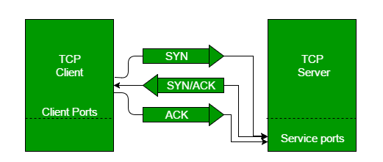

Why It Matters
- Ensures reliable communication by synchronizing sequence numbers.
- Prevents data loss and connection errors.
- Forms the basis for secure and ordered data transfer in TCP/IP networks

- TCP Options
TCP Options are extra parameters in the TCP header used to improve TCP performance and functionality.

Common TCP Options:
- MSS (Maximum Segment Size): Maximum data size in one TCP segment
- Window Scaling: Increases TCP window size for high-speed networks
- SACK (Selective Acknowledgment): Allows receiver to acknowledge specific packets
- Timestamp: Helps calculate round-trip time

Simple: TCP options provide additional features to optimize TCP communication.

- TCP Flags
TCP Flags are control bits in the TCP header used to control connection state and data flow.

Common TCP Flags:
- Synchronize (SYN): Start connection
- Acknowledgment (ACK): Acknowledge received data
- Finish (FIN): Close the connection
- Reset (RST): Reset/terminate the connection immediately
- Push (PSH): Send data immediately to the application
- Urgent (URG): Indicates urgent data in the packet

Short interview line:
TCP flags are control bits used to establish, manage, and terminate TCP connections.

- TCP Timers
TCP Timers control time-based events in TCP communication.

Common TCP Timers
- Retransmission Timer: Resends lost packets
- Persistence Timer: Prevents deadlock when window size is zero
- Keepalive Timer: Checks if connection is still active
- Time-Wait Timer: Ensures delayed packets are handled before closing connection

Simple: TCP timers manage retransmissions and connection reliability using time control.

- ARP
ARP stands for Address Resolution Protocol, it is used to find the MAC address of a device when we already know its IP address.

What is a MAC Address?
MAC address stands for Media Access Control address. It is a unique physical address given to every network device.

Think of it like this:
You know your friend’s name (IP address), but to call them, you need their phone number (MAC address). ARP helps you get that number.

Why ARP is needed?
Computers talk inside a local network using MAC addresses, not IP addresses. So, when one device wants to send data to another device in the same network
- It knows the destination IP
- But it needs the destination MAC
- ARP helps to find that MAC address

How ARP Works (Simple Steps)
- A device wants to send data and knows the destination IP address, but it needs the MAC address to deliver the data in the local network.
- It first checks its ARP cache to see if the MAC address for that IP is already saved.
- If the MAC address is not found, the device sends an ARP request as a broadcast to all devices in the network asking, “Who has this IP address?”
- All devices receive the request, but only the device with the matching IP address replies.
- The target device sends an ARP reply directly back, telling its MAC address.
- The sender stores this IP–MAC mapping in its ARP cache for future communication.
- Now the sender can send the actual data using the destination device’s MAC address.

Types of ARP

S. No | Type of ARP | What It Does / How It Works | When It’s Used / Purpose | Simple Meaning
1 | Normal ARP | Finds the MAC address of a device when its IP is known. Standard ARP request & reply. | Regular communication inside a local network. | “I know the IP, tell me the MAC.”
2 | Proxy ARP | A router replies to an ARP request for another device with its own MAC, tricking sender. | When devices are in different networks but appear local. | Router acts like a middleman.
3 | Gratuitous ARP | A device sends an ARP request for its own IP to check for duplicates or update tables. | To check duplicate IPs or update ARP tables. | “Hey everyone, this IP belongs to me.”
4 | Reverse ARP (RARP) | Finds IP address from a MAC address using a gateway/router table. | Used by old diskless systems at startup. | “I know my MAC, what’s my IP?”
5 | Inverse ARP | Finds IP address when the device’s MAC (link layer address) is known. | Used in Frame Relay / ATM networks where virtual circuits exist. | “I know the connection, what’s your IP?”

- Dynamic Host Configuration Protocol (DHCP)
DHCP is a network protocol that automatically gives devices an IP address and other network settings so they can connect and communicate on a network without manual configuration.
- Assigns a unique IP address to each device.
- Provides the subnet mask to define the local network range.
- Configures the default gateway for communication outside the local network.
- Supplies DNS server addresses for domain name resolution

Example: Laptop Connecting to Wi-Fi
- Laptop joins Wi-Fi → It doesn’t have an IP yet.
- Laptop asks for IP → Sends a request (Discover).
- Router replies → Offers an IP address and settings (Offer).
- Laptop accepts → Requests that IP (Request).
- Router confirms → Assigns the IP for a set time (Acknowledge).
- Laptop is ready → Can now browse the internet.

Role of DCHP in this example
- Automatically assigns a unique IP address to the laptop.
- Provides network settings like subnet mask, default gateway, and DNS servers.
- Manages the lease time so IPs are reused efficiently.
- Removes manual setup - you don’t have to type in IP details yourself.

Components of DCHP
S. No | Component Name | Purpose / Why It’s Used
1 | DHCP Server | Gives IP addresses
2 | DHCP Relay | Forwards DHCP requests
3 | DHCP Client | Requests IP address.
4 | IP Address Pool | Stores available IPs
5 | Lease | IP usage time.
6 | Options | Extra network settings
7 | Default Gateway | Path to other networks
8 | DNS Servers | Converts domain to IP

- Domain Name System (DNS)
The Domain Name System (DNS) is used to convert a domain name into an IP address, so a computer can locate the correct server on the internet.
- Converts domain names (e.g., www.geeksforgeeks.org) into IP addresses.
- Eliminates the need to remember numerical IP addresses.
- Works using a hierarchical structure of servers.
- Uses root, TLD, and authoritative DNS servers for resolution.
- Supports caching to improve speed and reduce network traffic.

Working of DNS
- User Request
You enter a website name in the browser (example: google.com).
- DNS Resolver Check
Your computer checks its local DNS cache.
If IP is not found, it sends a request to a DNS resolver (usually your ISP).
- Root DNS Server
Resolver asks the Root DNS server where the domain information is located.
- TLD Server
Root server directs the request to the Top-Level Domain (TLD) server (.com, .org, .net).
- Authoritative DNS Server
TLD server points to the authoritative DNS server which stores the real IP address.
- IP Address Returned
The authoritative server sends the IP address back to the resolver.
- Website Opens
The resolver sends the IP to your computer and the browser connects to the server.

Example of DNS
- You open your browser and type www.google.com
- But computers don’t understand names like this. They understand only IP addresses (like 142.250.183.206).

Role of DNS in this example:
When you type www.google.com this happens
- Your computer asks: “What is the IP address of www.google.com?”
- DNS searches in its hierarchical structure
- Root server
- .com server
- google.com server
- DNS finds the correct IP address.
- DNS sends back the IP address to your computer.
- Your browser connects to that IP address and loads the website.

- DNS over HTTP (DoH)
- DNS (Domain Name System): Translates domain names (like example.com) into IP addresses.
- HTTPS (Hypertext Transfer Protocol Secure): Encrypts communication between your device and a server.

So, DoH = DNS queries sent securely over HTTPS instead of the traditional unencrypted DNS protocol.

This ensures:
- 🔒 Privacy: outsiders (like ISPs or attackers) can’t easily see which sites you’re visiting.
- 🛡️ Security: prevents tampering or spoofing of DNS responses.
- 🌐 Modern adoption: browsers like Firefox, Chrome, and Edge support DoH for safer browsing.

- What is Ping?
Ping is a network diagnostic utility used to test the reachability of a host (device/server) on an IP network and to measure the round-trip time (RTT) for packets sent from the source to the destination and back.
(or)
Ping is a network tool used to check if a device or server on a network is reachable and how long it takes for data to travel to it and back.

How Ping Works
- You run the command ping google.com
- Your computer sends a small message called an Echo Request using Internet Control Message Protocol (ICMP).
- The message travels through the network to the destination server.
- If the server is reachable, it sends back an Echo Reply.
- Your computer calculates the round-trip time (RTT) — the time taken for the message to go to the server and return.

Example Output
Reply from 142.250.183.14: time=24ms

Advantages of Ping
- Checks Network Connectivity
Ping helps verify whether a device or server is reachable on a network.
- Measures Network Latency
It calculates the round-trip time (RTT) for packets between the source and destination.
- Helps in Troubleshooting
Network administrators use ping to quickly identify network issues such as connectivity problems.
- Detects Packet Loss
Ping can show if packets are being lost during transmission, indicating network instability.
- Simple and Fast Diagnostic Tool
It is a basic and widely available tool in most operating systems for quick network testing.
- Verifies Server Availability
It can confirm whether a server or host is active and responding.

- Traceroute
Traceroute is a network diagnostic tool used to trace the path (route) that packets take from a source computer to a destination server on a network.

It helps to identify
- The number of hops (routers) between source and destination
- Where delays occur in the network
- Where the connection fails

How Traceroute Works (5 Simple Points)
- You run the command
Example: tracert google.com.
- Traceroute sends a packet with TTL = 1
The first router receives it and sends a reply.
- Traceroute sends another packet with TTL = 2
The packet reaches the second router, which sends a reply.
- This process continues
TTL increases (3, 4, 5…), so packets reach each router in the path.
- When the packet reaches the destination server
The server replies, and traceroute stops, showing all hops in between.

- Telnet – Interview Explanation (Simple Points)
Telnet is a network protocol and tool used to remotely connect to another computer or server over a network using the command line

How Telnet works ?
- User runs the command
telnet server_ip port
- Telnet tries to connect to the remote server using TCP port 23 (default).
- If the connection is successful, a remote terminal session opens.
- The user can run commands on the remote server as if they are logged into that system.
- The server sends responses back and they appear in your terminal.

Example
telnet google.com 80
This checks if port 80 (HTTP) on the server is reachable.

Why Telnet is Used (Simple Points)
- Remote access
It allows you to connect and control another computer/server remotely using the command line.
- Check port connectivity
It helps check whether a specific port on a server is open or reachable.
- Troubleshooting network issues
Used by administrators to test services like HTTP, SMTP, FTP, etc.
- Testing server service
You can manually send commands to a service to verify if it is responding.
- Network debugging
Helps identify connection problems between client and server.

- Hypertext Transfer Protocol (HTTP) & Hypertext Transfer Protocol Secure (HTTPS)

What is HTTP?
HTTP stands for HyperText Transfer Protocol. It is a communication protocol used to transfer data between a web browser (like Google Chrome or Firefox) and a web server on the internet.

Simple Meaning:
When you open a website like Google, your browser sends an HTTP request to the server, and the server sends back an HTTP response (like a webpage, image, or data).

Example: When you type: http://example.com your browser
- Sends a request to the server.
- The server responds with the webpage.
- Your browser displays it.

Important Points:
- HTTP works on Port 80
- It is not secure
- Data is sent in plain text
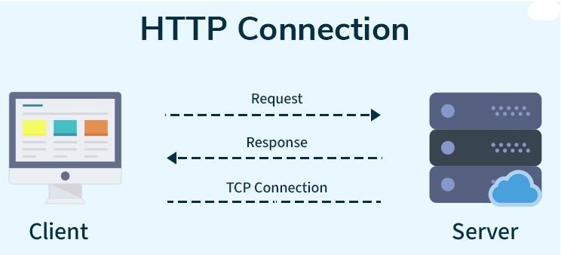
How HTTP Works: Step-by-Step Process
Here’s how HTTP works when you visit a website:
- Open Web Browser: First, you open your web browser and type a website URL (e.g., www.example.com).
- DNS Lookup: Your browser asks a Domain Name System (DNS) server to find out the IP address associated with that URL. Think of this as looking up the phone number of the website.
- Send HTTP Request: Once the browser has the website’s IP address, it sends an HTTP request to the server. The request asks the server for the resources needed to display the page (like text, images, and videos).
- Server Response: The server processes your request and sends back an HTTP response. This response contains the requested resources (like HTML, CSS, JavaScript) needed to load the page.
- Rendering the Web Page: Your browser receives the data from the server and displays the webpage on your screen.

Server:
A server is a computer system or software that provides services, resources, or data to other computers (called clients) over a network.

What is HTTPS?
HTTPS stands for HyperText Transfer Protocol Secure. It’s the secure version of HTTP, the protocol used for communication between your web browser and a website.

One-line meaning:
HTTPS = Secure communication between browser and server

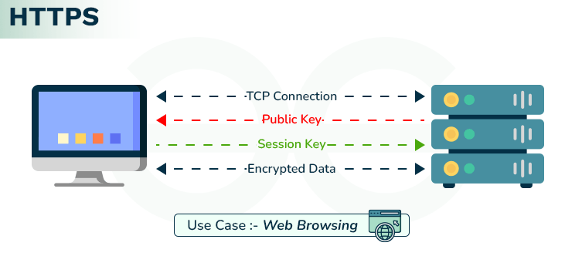
Example:
When you open https://google.com the data is Encrypted, Secure, Safe for passwords & banking

How HTTPS Works?
- You type a website starting with https:// in your browser (for example https://google.com) using a browser like Google Chrome.
- The browser connects to the website’s server.
- A server is a computer system or software that provides services, resources, or data to other computers (called clients) over a network.
- For example, servers owned by Google are located in Google data centers and run Google’s website.
- The server sends its SSL/TLS certificate (digital certificate that proves the server’s identity).
- The browser verifies the certificate with a trusted Certificate Authority (CA).
- If the certificate is valid, the browser and server perform a TLS handshake using Transport Layer Security.
- During this process, both create a shared secret encryption key.
- All communication between the browser and server is now encrypted.
- The browser securely receives the webpage data and displays the secure webpage with the lock icon 🔒.

Difference between HTTP & HTTPS

S. No | Feature | HTTP | HTTPS
1 | Security | Data is sent as plain text — easy to intercept. | Data is encrypted — safer from hackers.
2 | Port | Uses port 80 by default. | Uses port 443 by default.
3 | Trust | Browsers may label it “Not Secure.” | Shows a padlock in the address bar.
4 | Speed | Slightly slower on old systems. | Often faster due to newer protocols and optimizations.
5 | Use case | Suitable for public or non-sensitive info. | Best for sensitive data like payments, logins, personal info.

- HTTP Request Methods
HTTP Request Methods are used by a client (browser) to tell the server what action to perform on a resource.

S. No | Method | Purpose | Typical Use Case
1 | GET | Retrieve resource data | Fetching a webpage, API data
2 | HEAD | Same as GET but without body | Checking metadata, headers
3 | POST | Submit data to server | Creating new records, form submissions
4 | PUT | Replace resource entirely | Updating a record fully
5 | PATCH | Partially update resource | Updating specific fields
6 | DELETE | Remove resource | Deleting a record
7 | OPTIONS | Discover server-supported methods | Preflight requests in CORS
8 | TRACE | Echo request for debugging | Diagnostics (rarely used)
9 | CONNECT | Establish tunnel (e.g., HTTPS proxy) | Secure connections via proxy

- HTTP Response Codes
HTTP Response Codes are status codes sent by the server to the client (browser) to indicate the result of a request.

Class | Range | Meaning | Examples
1xx – Informational | 100–199 | Request received, processing continues | 100 Continue, 101 Switching Protocols
2xx – Success | 200–299 | Request successfully processed | 200 OK, 201 Created, 204 No Content
3xx – Redirection | 300–399 | Further action required (redirection) | 301 Moved Permanently, 302 Found, 304 Not Modified
4xx – Client Errors | 400–499 | Error caused by the client request | 400 Bad Request, 401 Unauthorized, 403 Forbidden, 404 Not Found
5xx – Server Errors | 500–599 | Server failed to process the request | 500 Internal Server Error, 502 Bad Gateway, 503 Service Unav

- Explain about Proxy and working of Proxy
What is a Proxy Server?
A Proxy Server is an intermediary (middleman) between a client (your device) and the internet.
- Client → Proxy → Internet → Proxy → Client
- It hides your real IP address and sends requests on your behalf.

Working of a Proxy (Step-by-Step)
- User sends request
- Example: You enter a website URL in your browser.
- Request goes to Proxy Server (not directly to internet)
- Your system is configured to use a proxy.
- Proxy checks the request
- Applies rules (security, filtering, authentication)
- Can block or allow the request
- Proxy forwards request to the Internet (server)
- Uses its own IP address, not yours
- Server responds to Proxy
- Website sends data back to the proxy
- Proxy sends response back to Client
- You receive the webpage

What does Proxy archives
- Hides your IP → keeps you anonymous
- Adds security → blocks harmful sites
- Controls access → restricts websites
- Speeds up browsing → via caching
- Monitors usage → tracks activity
- Bypasses restrictions → access blocked content

- Explain about Firewall and working of Firewall
What is a Firewall?
A Firewall is a security system that monitors and controls incoming & outgoing network traffic based on rules.

Working of Firewall (Step-by-Step)
- User sends/receives network request
- Example: Open facebook.com
- Traffic reaches Firewall
- All incoming & outgoing traffic passes through firewall
- Firewall checks rules (allow/deny)
- Example: “Block social media”, “Allow HTTPS”
- Firewall decides (Allow / Block)
- Facebook → ❌ Blocked
- Company portal → ✅ Allowed
- If allowed → forwarded to destination
- Request goes to the server
- If blocked → request is dropped
- Access denied
- Logs the activity for monitoring
- Records allowed/blocked traffic

What Firewall Achieves
- Blocks unauthorized access → protects network
- Allows trusted traffic only → rule-based control
- Prevents attacks → like hacking attempts
- Monitors traffic → tracks incoming/outgoing data
- Protects internal network → from external threats
- Stops suspicious activity → based on rules

- Difference between Proxy and Firewall
Feature | Proxy | Firewall
Purpose | Privacy + control | Security + protection
Role | Middleman | Security guard
IP | Hides IP | Does not hide IP
Action | Forwards requests | Allows/blocks traffic
Decision | Forward, cache, modify | Only allow or block
Security | Basic security | Strong security
Bypass | Yes (access blocked sites) | No (enforces restrictions)

